Sonarqube installation

Sonarqube port number :- 9000

. yum install java-1.8.0-openjdk –y

. sudo wget –O /etc/yum.repos.d/ <http://downloads.sourceforge.net/project/sonar-pkg/rpm/sonar.repo>

. yum install sonar –y

. service sonar start

. step 1:-

Install java

Install repo

.below showing fig in that directory there is no yum packages

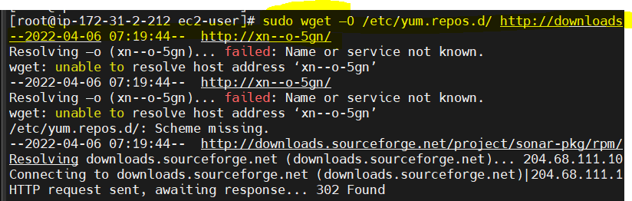

. change directory

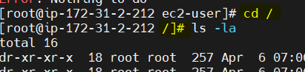

. go to cd /etc/yum.repo.d

. up date package

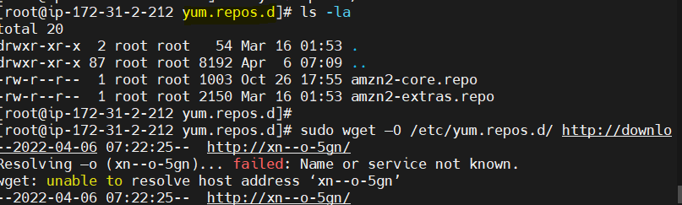

. install sonar

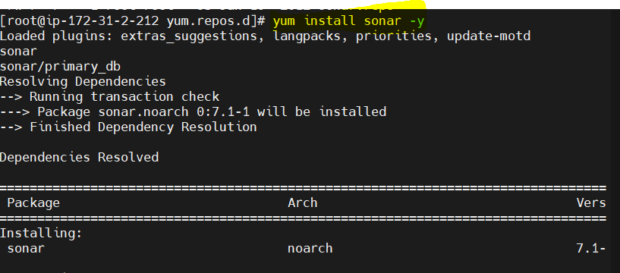

. start sonar service

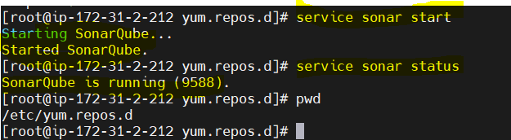

. go to google paste ip address:9000

.log in sonar

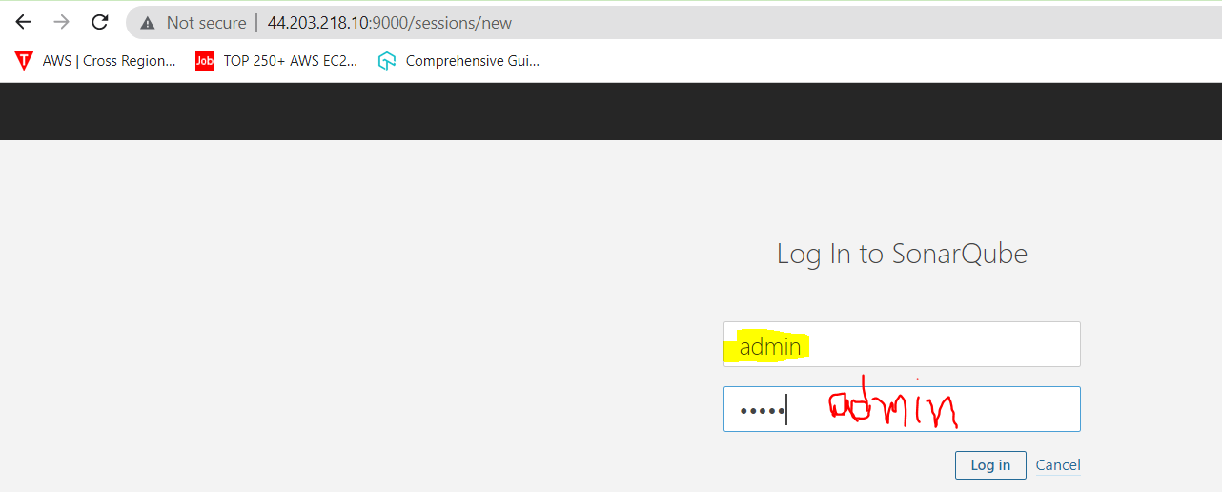

. generate token 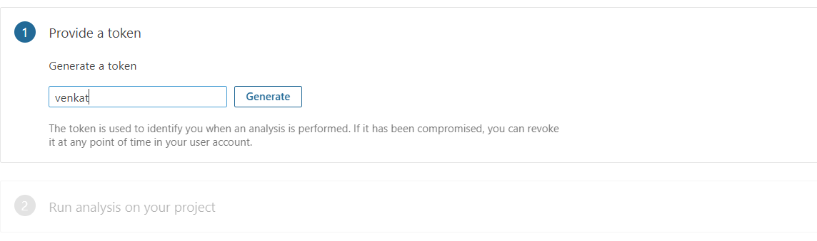

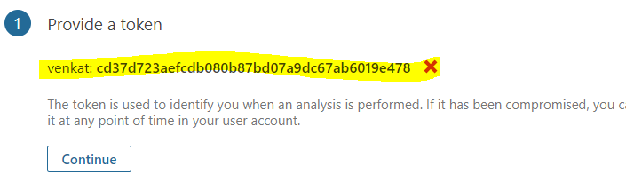

. copy token on notepad

.click continue

. skip tutorial

. sonarqube dash board here

